THE WHO, WHAT, WHEN, WHERE & WHY GUIDE TO STRESS

WHAT IS STRESS?
Stress is what we feel when demands made on us go beyond what we are able to cope with.
WHY DO WE GET STRESSED?
It’s in our nature! Historically, humans became stressed because of the dangers that faced us (think sabre tooth tigers), and our sympathetic nervous system developed a response that would help us react when faced with danger. This is the ‘fight/flight/freeze’ responses. These responses are what make up part of our survival instincts – and it is why we have continued to exist for as long as we have.
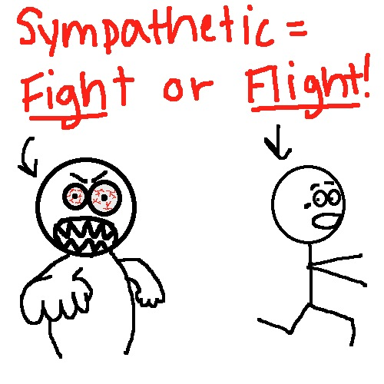

SO, STRESS IS…NORMAL?
Yes! Stress is something that we can all experience when our lives become challenging, and a little bit of stress can be a good thing (it sharpens our senses, raises our game, helps us step up to challenges)

WHAT CAUSES STRESS?
- School (course work, exams)
- Relationships (friends, parents, siblings)
- Change/transitions (future, endings, new beginnings)
- Difficult and challenging life events

WHY IS IT IMPORTANT TO NOTICE WHEN I’M FEELING STRESS?
Too much stress, which goes on too long, and without letting up, stops being helpful. It can damage your health, your mood, your relationships, and your quality of life

HOW DO I KNOW IF I’M STRESSED?
PHYSICAL SIGNS:
- Tired (can’t relax enough to sleep)
- Health problems (digestive, tummy troubles)
- Headaches, muscle aches, back pain
- Dizziness, nausea
- Changes in appetite

PSYCHOLOGICAL SIGNS:
- Irritable, moody
- Arguing more with friends and family
- Feeling anxious, worried, racing thoughts
- Low mood, feeling ‘stuck’
- Hard to make decisions about everyday things

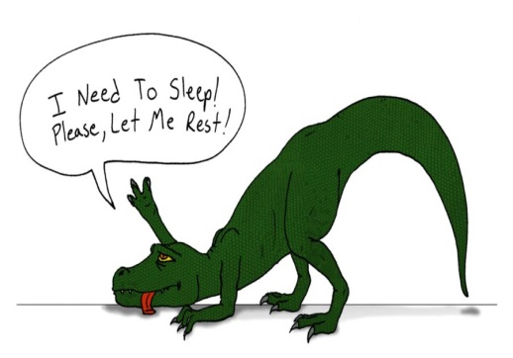
WHAT CAN I DO TO HELP EASE THE STRESS?
10 STRESS-BUSTING TIPS
- ORGANISE your time and reduce demands by taking them on one-at-a-time
- Take up regular EXERCISE
- Eat HEALTHY food (fruit and veggies)
- Make sure you get enough ‘ZZZZs’ by creating and sticking to a regular SLEEP routine
- Make time to do things you ENJOY and that make you feel GOOD
- TALK IT OUT: share with people you trust how you are feeling
- CONNECT with people: spend time with friends and/or family
- ACCEPT that you can’t control everything (like taking exams)
- BE KIND to yourself (there is only one you and you have so much to offer)
- Make sure you find ways to RELAX and leave room to BREATH (try Mindfulness breathing or meditation)

FEELING STRESSED? Try some ‘Mindfulness Colouring’; it helps to calm your mind, centre your thoughts, and focus your brain.

SOME USEFUL WEBSITES WITH MORE ADVICE & INFORMATION
- http://www.bbc.co.uk/programmes/p0215sqv (BBC Radio 1 ‘Advice’ page with information on different issues affecting young people)
- www.thecalmzone.net (The Campaign Against Living Miserably focuses on supporting men of all ages across the UK who feel anxious or depressed; with information on a range of different issues)
- www.youngminds.org.uk (lots of information for young people on all aspects of mental health)
- www.kooth.com (free & confidential online support, including counselling, for young people in Lewisham; all you need to get started is to register with them)
- www.childline.org.uk (website has lots of information OR you can phone them at any time on 0800 1111; calls are free & confidential)
Try out a ten minute mindfulness exercise using the link below:
https://soundcloud.com/mentalhealthfoundation/mindfulness-10-minute-practice

