There are lots of ways you can see plays and keep working on your skills over the summer. Here are a few examples:
DRAMA - SUMMER 2020
Explore ‘Culture In Quarantine’ on the BBC. Loads of exciting content including Drama, Shakespeare, Arts, Music Audio www.bbc.co.uk/arts | Get ready for GCSEs by studying BBC Bitesize  AQA Drama  www.bbc.co.uk/  bitesize/examspecs/ zdb6xyc | Have fun learning tongue twisters and improving your vocal skills.  http://www.bbc.co.uk/languages/yoursay/tongue_twisters.shtml | Subscribe to ‘Organic Acting’ on YouTube. This channel will help with your knowledge and skills tps://www.youtube.com/channel/ UCIn86ioRBEeJh8UL4rK1pBw
Learn a speech from Hamlet with  ‘The Big Read’ (featuring Martin  Freeman)  www.bbc.co.uk/bitesize/articles/zhw796f  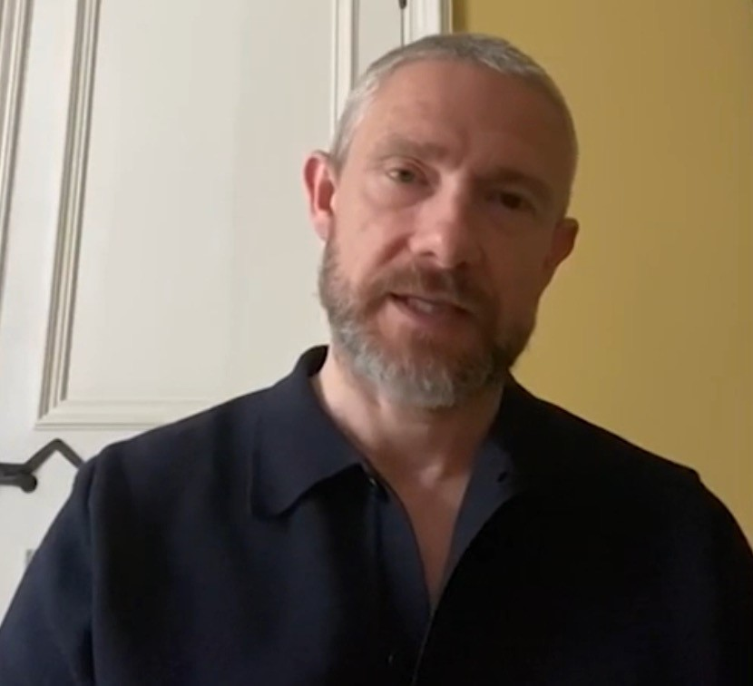 | 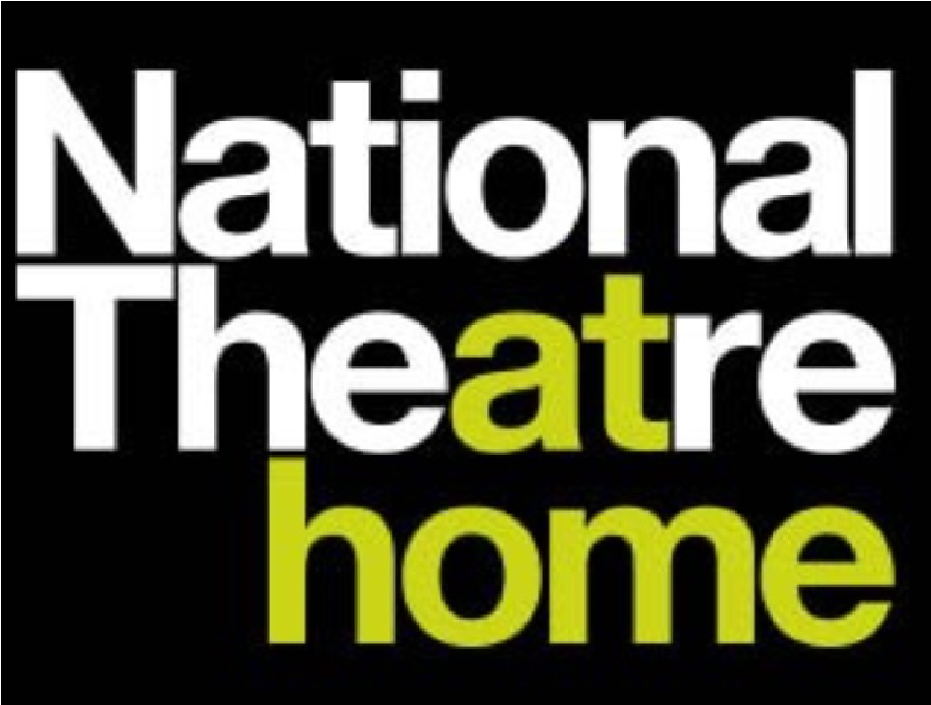  Subscribe to the National Theatre at home here:  www.youtube.com/user/ ntdiscovertheatre | www.tamasha.org.uk/education/bitesize-playwrighting  Learn how to write a play and enter it into tamasha’s playwritng competition.
Take part in an online summer school with our friends at mousetrap.  https://www.mousetrap.org.uk/online-summer-school | Watch online shows @OldVic You Tube channel.  www.youtube.com/channel/UCmh6MmjVkAnzTNyKHIIOruw | Get to Lewisham, Catford, Crofton, or Forest Hill Library and borrow a play - the librarian can help you! Then you could organise a play reading with family and friends on Zoom, MsTeams or Skype. | WATCH: www.rifcotheatre.com/shows/mushy-lyrically-speaking  Mushy, a young man with a debilitating stammer, finds himself at the centre of a television documentary. In a moment of inspiration from his teacher, Mr. Burton, he starts to find a rhythm in his voice through music. Social media erupts hailing it a miracle cure and both teacher and pupil become overnight celebrities.

